**UML DIAGRAM FOR COMPUTE QUOTIENT AND REMAINDER**

**Aim:**

To draw UML diagram for compute quotient and remainder using umbrello tool.

**UML DIAGRAM**

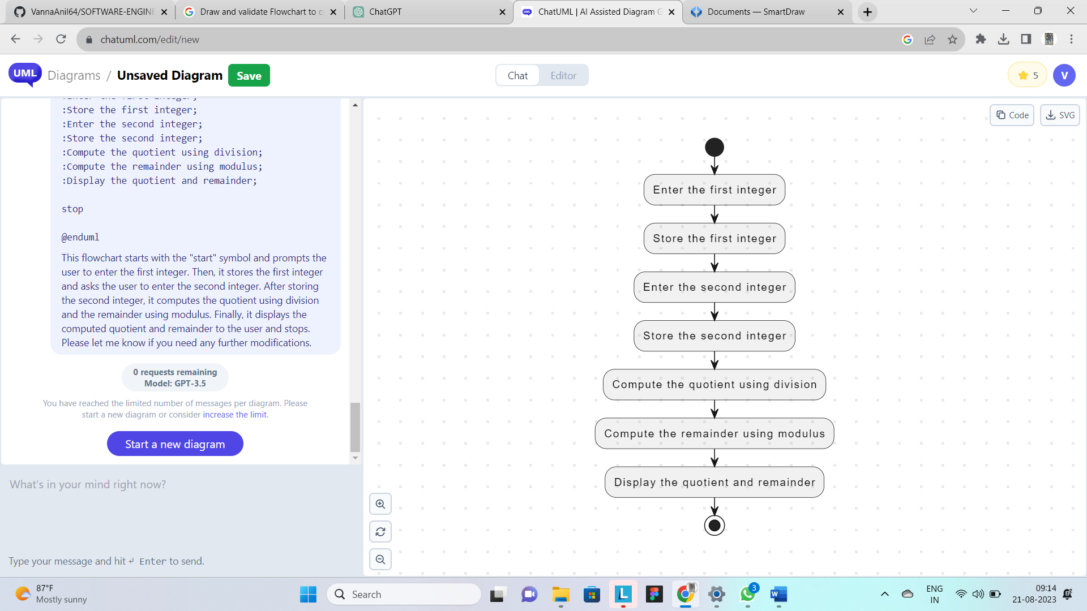

**RESULT**

Hence these diagrams for compute quotient and remainder are drawn and verified successfully.